附件一、各機關聘請國外顧問、專家及學者來臺工作期間支付費用最高標準表
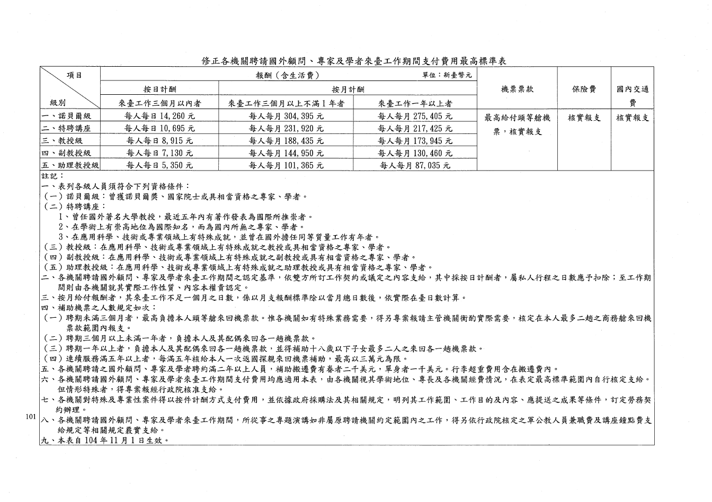

附件二、國立臺北科技大學補助國際短期訪問特聘教授申請書
申請人姓名  (Name) |  |  |  | 申請單位(系所)  (Department)
申請人電子信箱
(E-mail)
申請人電話  (Telephone) | 公(Office): 手機(Cell Phone):
國際短期訪問特聘教授基本資料(International Distinguished Visiting Professor Identity Information)
特聘教授姓名  (IDVP Name) |  |  |  | 性別  (IDVP Gender) |  | 男(Male)  女(Female)
特聘教授所屬機構
(IDVP Affiliation)
職 稱(IDVP Title)
所屬機構服務期間  (IDVP Service Period in Original Affiliation) | 自(From) 年(yyyy) 月(mm) 日(dd)  至(To) 年(yyyy) 月(mm) 日(dd)
特聘教授電子信箱
(IDVP E-mail)
特聘教授最高學歷
(IDVP Highest Diploma)
特聘教授專業或專長
(IDVP Expertise)
特聘教授留訪期間  (IDVP Stay Period) | 自(From) 年(yyyy) 月(mm) 日(dd)  至(To) 年(yyyy) 月(mm) 日(dd)
資格證明  (Qualifications) | □提供最高學歷證明文件影本(IDVP highest diploma copy is required)  □申請前3年FWCI值均高於本校平均1.5倍且不低於1.2之證明  (IDVP should provide the FWCI record, which is required higher than Taipei Tech. average 1.5 times and higher than 1.2 in the nearly three years.)
研究計畫主題
(Subject of Project)
申請  本校補助項目與金額  (Apply Reimbursement Items and Amount) | 往返機票費(Round-Trip Air Fare)__________________元(NTD)  日支生活費(Living Expenses)：  __________來訪日數(Stay Days)× ___________日支費(Daily Allowance)  ＝______________元(NTD)  合計(Total)__________________________元(NTD)  註：補助日支生活費及最短航程往返經濟艙機票費，每案新臺幣三十萬元為限，並於結束訪問後一個月內，依本校規定核實報銷。  Remark：The daily living allowance and economy class round-trip air fare for the shortest flight are limited to NT $ 300,000 per application, and within one month after the end of the visit, reimbursement is verified by the receipts in accordance with the regulations of Taipei Tech.
申請人  (Applicant) |  | 單位(系所)主管  (Department Head) | 院級主管  (Dean of the College) |  | 研發處  (Office of Research  and Development)
*請加註簽章日期
備註：依本要點來訪研究期間，應遵守學術倫理相關規定，如有違反學術倫理之情事，準用本校「教師違反送審教師資格規定及其他違反學術倫理案件處理要點」，將取消補助追還已撥付之費用外，並依相關法規辦理。

附件三、研究計畫書
  - 研究主題
  - 時程規劃
  - 國際短期訪問特聘教授來訪與本校師生之合作模式及預估效益
  - 申請人所能提供給國際短期訪問特聘教授研究相關協助
(如儀器設備、研究空間、研究助理及研究資料庫等)
  - 預期結果
    - 對於本校學術研究提升及跨領域應用之貢獻

    - 預期完成之研究成果及績效

附件四、國際短期訪問特聘教授榮譽事蹟
- 近五年期刊論文目錄
- 歷年獲獎紀錄
- 其它榮譽紀錄

